JM Reference Software v16.1 with XML tracefile generation

General
Version 16.1 of the JM Reference software has been adjusted by Ghent University – IBBT in order to enable the generation of an XML-based trace file containing detailed information on the encoded bit stream format.
Changes have been made to the following source files for enabling the trace file generation:
- ldecod/src/image.c
- ldecod/src/ldecod.c
- ldecod/src/macroblock.c
- ldecod/src/mbuffer.c
- ldecod/src/output.c
- ldecod/inc/global.h
- ldecod/inc/mbuffer.h
Changes made for trace file generation are placed between a '/***** XML_TRACE_BEGIN ****/' and a '/****** XML_TRACE_END *****/' comment line. In addition, some new files are needed which simplify the creation of the XML trace file. These files are located in the ldecod/xmltracefile/src and the ldecod/xmltracefile/inc directories.

Tracefile overview
Currently, the following information is extracted during the decoding process and stored in the trace file (version 1.4):
For every non-picture (NALU type >= 6)
- NAL unit information
NAL unit information:
- Num - NAL unit number according to position in the bit stream
- Type - NALU type as defined in Table 7-1 of ITU-Rec. H.264
- TypeString - String identifying NALU type (Redundant information)
- Length - Size of the NALU in bytes
For every picture:
- id
- poc - Picture Order Count
- GOPNr - GOP number to which this picture belongs
- SubPicture information (Represents frame or field data. In case of interlaced content, each picture contains two <SubPicture> elements for the top and bottom field.)
For every subpicture:
- structure - integer indicating whether the subpicture contains frame or field data
(0 = frame data, 1 = top field data, 2 = bottom field data)
- Slice information
For every slice:
- num
- Type _ Slice type as defined in Table 7-6 of ITU-Rec. H.264
- TypeString - String identifying the slice type (Redundant information)
- NAL unit information
Note: this information can occur up to three times in case of data partitioning
- Macroblock information
For every macroblock:
- num
- QP_Y
- Type - Macroblock type as defined in tables 7-11, 7-12, 7-13 and 7-14 of ITU-Rec. H.264
- TypeString - String identifying the macroblock type (Redundant information)
- PredModeString - String identifying the macroblock prediction mode (I, SI, P or B)
- SkipFlag - true if the current macroblock is a P_SKIP or a B_SKIP
- Position - X and Y coordinate (in pixels) of the current macroblock
- MotionVector information
or
Submacroblock information (in case of B_8x8 or P_8x8 macroblock)
- Coefficients
For every submacroblock:
- num
- Type - Submacroblock type as defined in tables 7-17 and 7-18 of ITU-Rec. H.264
- TypeString - String identifying the submacroblock type (Redundant information)
- MotionVector information
For every motion vector:
- list - list 0 or list 1 prediction
- RefIdx - index in reference picture list of the reference picture to be used for prediction
- Difference - horizontal and vertical motion vector component difference
- Absolute - horizontal and vertical motion vector component

The structure of the XML trace file is also depicted in the picture below.
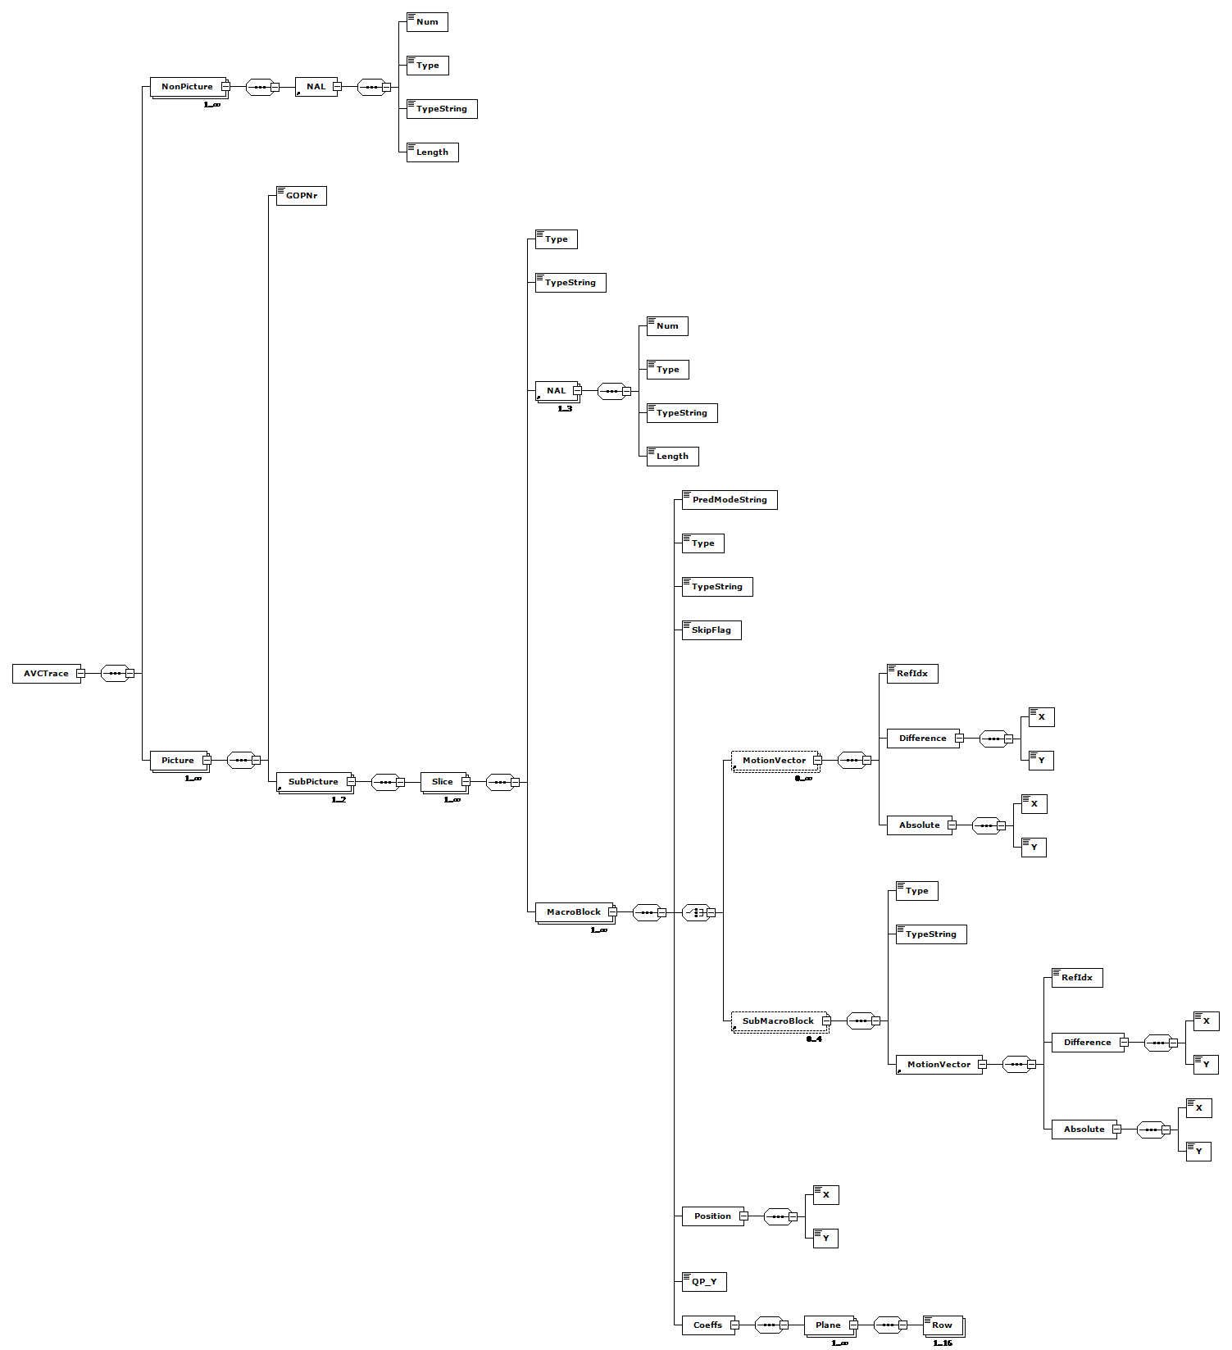

Enhanced error concealment
Since the impaired video sequences cannot be decoded properly with the H.264/AVC reference software except in the simplest cases of loss patterns, we adjusted the JM Reference Software version 16.1 to enable error concealment. As a concealment technique, frame copy is used. To start decoding a video stream, first the decoder waits for an Instantaneous Decoder Refresh (IDR) picture. Frames preceding the IDR picture are dropped. From then on, the decoder relies on Picture Order Count (POC) and frame number, which are present in the slice header, to restore impairments. These parameters are used to detect three different loss scenarios. First, a loss of an IDR picture can be detected when the frame number decreases instead of increases like during loss-free behaviour. An exception to this rule is when the maximum frame number is reached, because then the frame number is reset to zero again. Second, loss of reference frames can be detected when the frame number increases with more than one. For every missing frame number, a reference frame is included in the decoded video. Finally, the absence of non reference frames is detected with the POC. Gaps in the POC indicate losses of non reference frames and these are inserted in the video stream as well. For each of these scenarios, the lost frames are replaced with the nearest frame in time.

Sample configuration file
test.264 ........H.264/AVC coded bitstream
output.yuv ........Output file, YUV/RGB
test_rec.yuv ........Ref sequence (for SNR)
1 ........Write 4:2:0 chroma components for monochrome streams
0 ........NAL mode (0=Annex B, 1: RTP packets)
0 ........SNR computation offset
2 ........Poc Scale (1 or 2)
500000 ........Rate_Decoder
104000 ........B_decoder
73000 ........F_decoder
leakybucketparam.cfg ........LeakyBucket Params
1 ........Err Concealment(0:Off,1:Frame Copy,2:Motion Copy)
2 ........Reference POC gap (2: IPP (Default), 4: IbP / IpP)
2 ........POC gap (2: IPP /IbP/IpP (Default), 4: IPP with frame skip = 1 etc.)
0 ........Silent decode
1 ........Enable Deblocking filter in intra only profiles (0=disable, 1=filter according to SPS parameters)
Test_trace.xml ........XML trace
4 ........XML trace log level

This is a file containing input parameters to the JVT H.264/AVC decoder.
The text line following each parameter is discarded by the decoder.

For bug reporting and known issues see:
https://ipbt.hhi.de

Depending on the XML trace log level, more detailed information can be added to the trace file Possible values with corresponding logging information are:
- 0 => trace up to Slice and NAL header
- 1 => add Macroblock info
- 2 => add SubMacroblock info
- 3 => add MotionVector info
- 4 => add Coefficients

Obtaining the software
The software can be downloaded from VQEG’s Tools and Subjective Labs Setup web page at http://vqegstl.ugent.be.

